BE ECA Compliance for Log360

**Tagline** – Automate BE ECA compliance with electronic communications security monitoring using Log360.

**Overview**
The BE ECA Compliance extension for Log360 helps Belgian organizations ensure compliance with the Electronic Communications Act requirements. By integrating this extension, IT and security teams gain deep visibility into their electronic communications security posture.
Log360 continuously collects and correlates log data from Active Directory, Windows, Unix/Linux, Microsoft 365, cloud platforms, and network devices, mapping events directly to ECA standards. Security teams can track compliance status in real time, investigate incidents quickly, and generate audit-ready reports with a single click.

**Key Features:**
- Generate comprehensive audit-reports mapped to each of the BE ECA electronic communications controls.
- Analyzes user and entity behavior for insider threats and unusual communication patterns across systems.
- Provides powerful search capabilities with filters, keywords, and time-based queries for forensic investigations.
- Export reports in PDF and CSV format for auditors, management, or regulatory submissions.

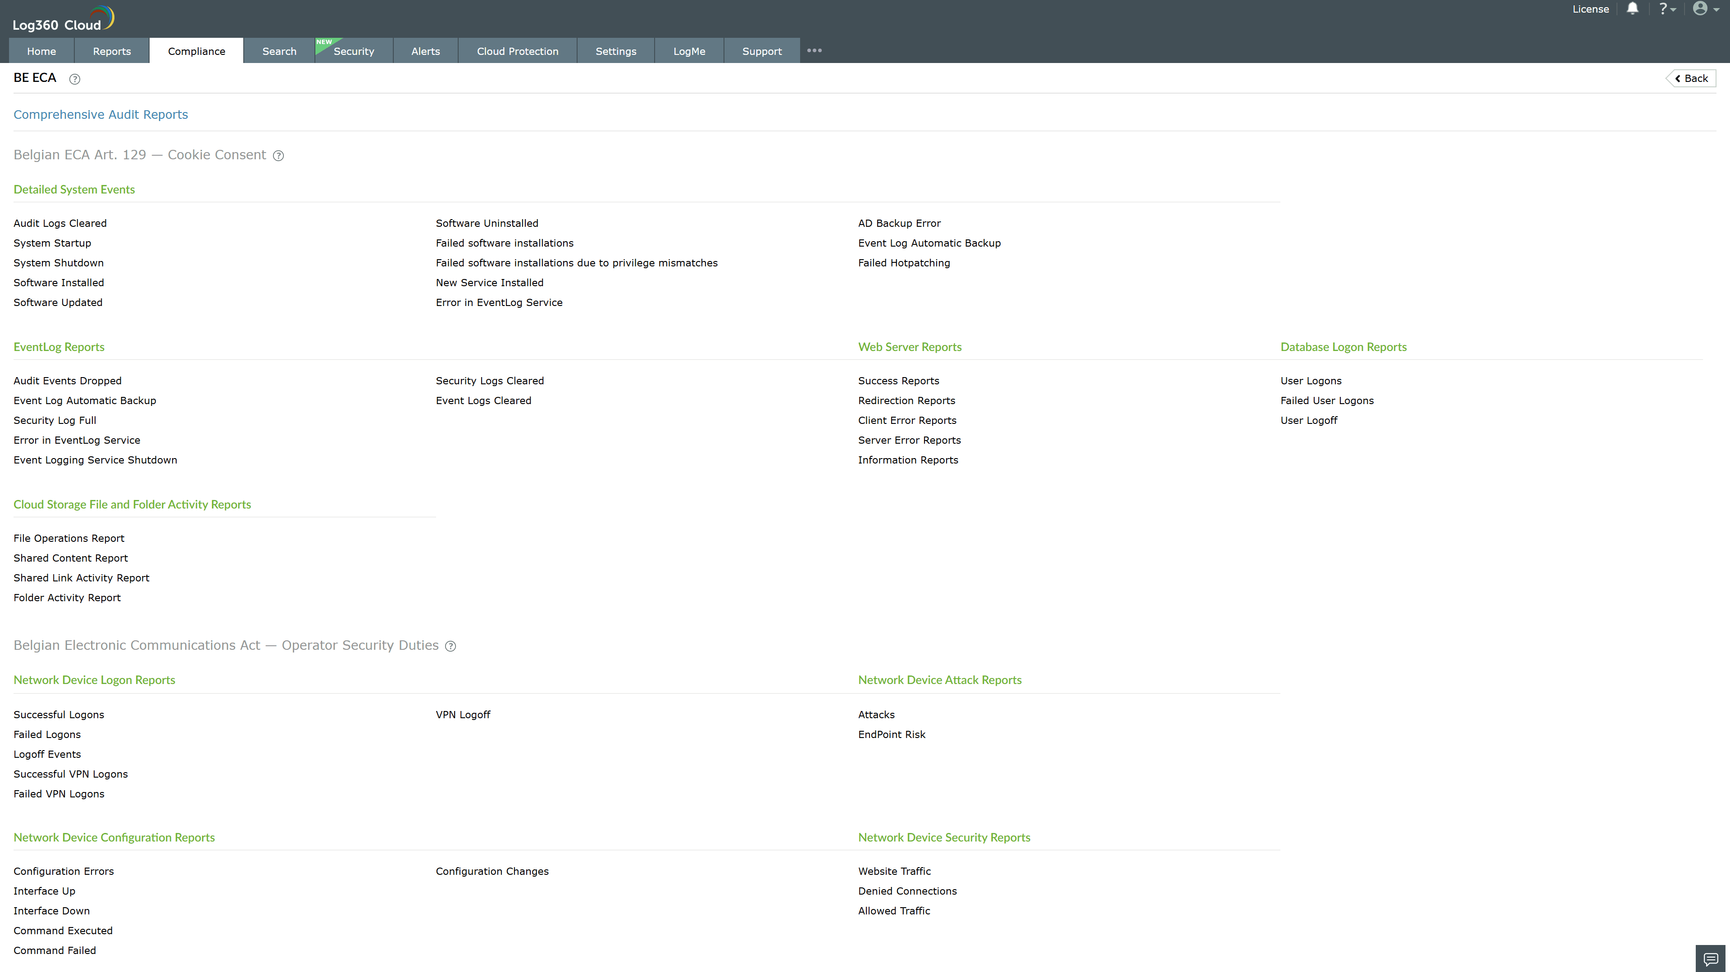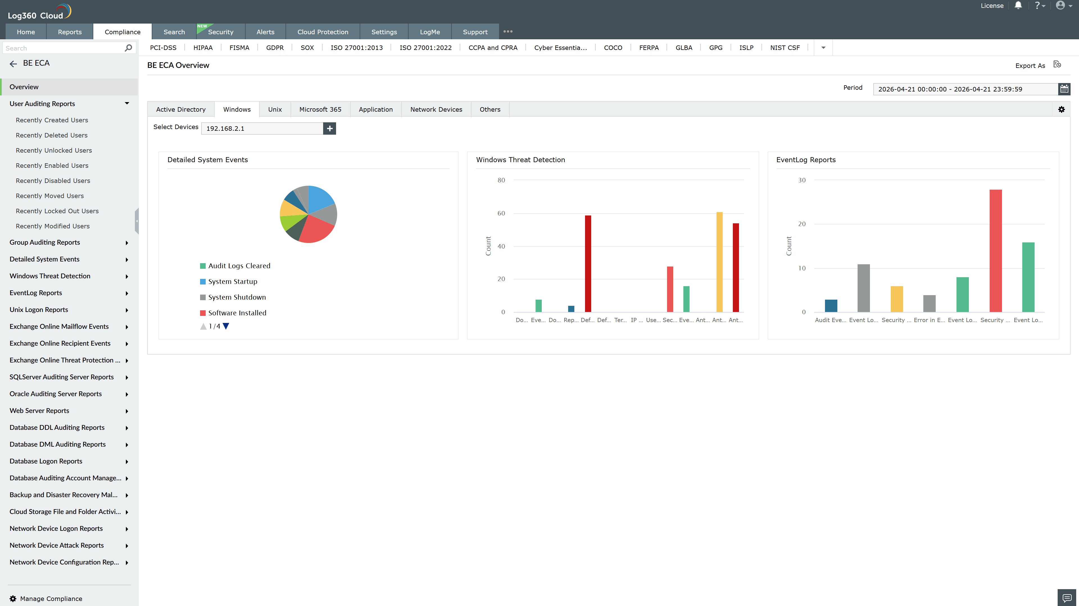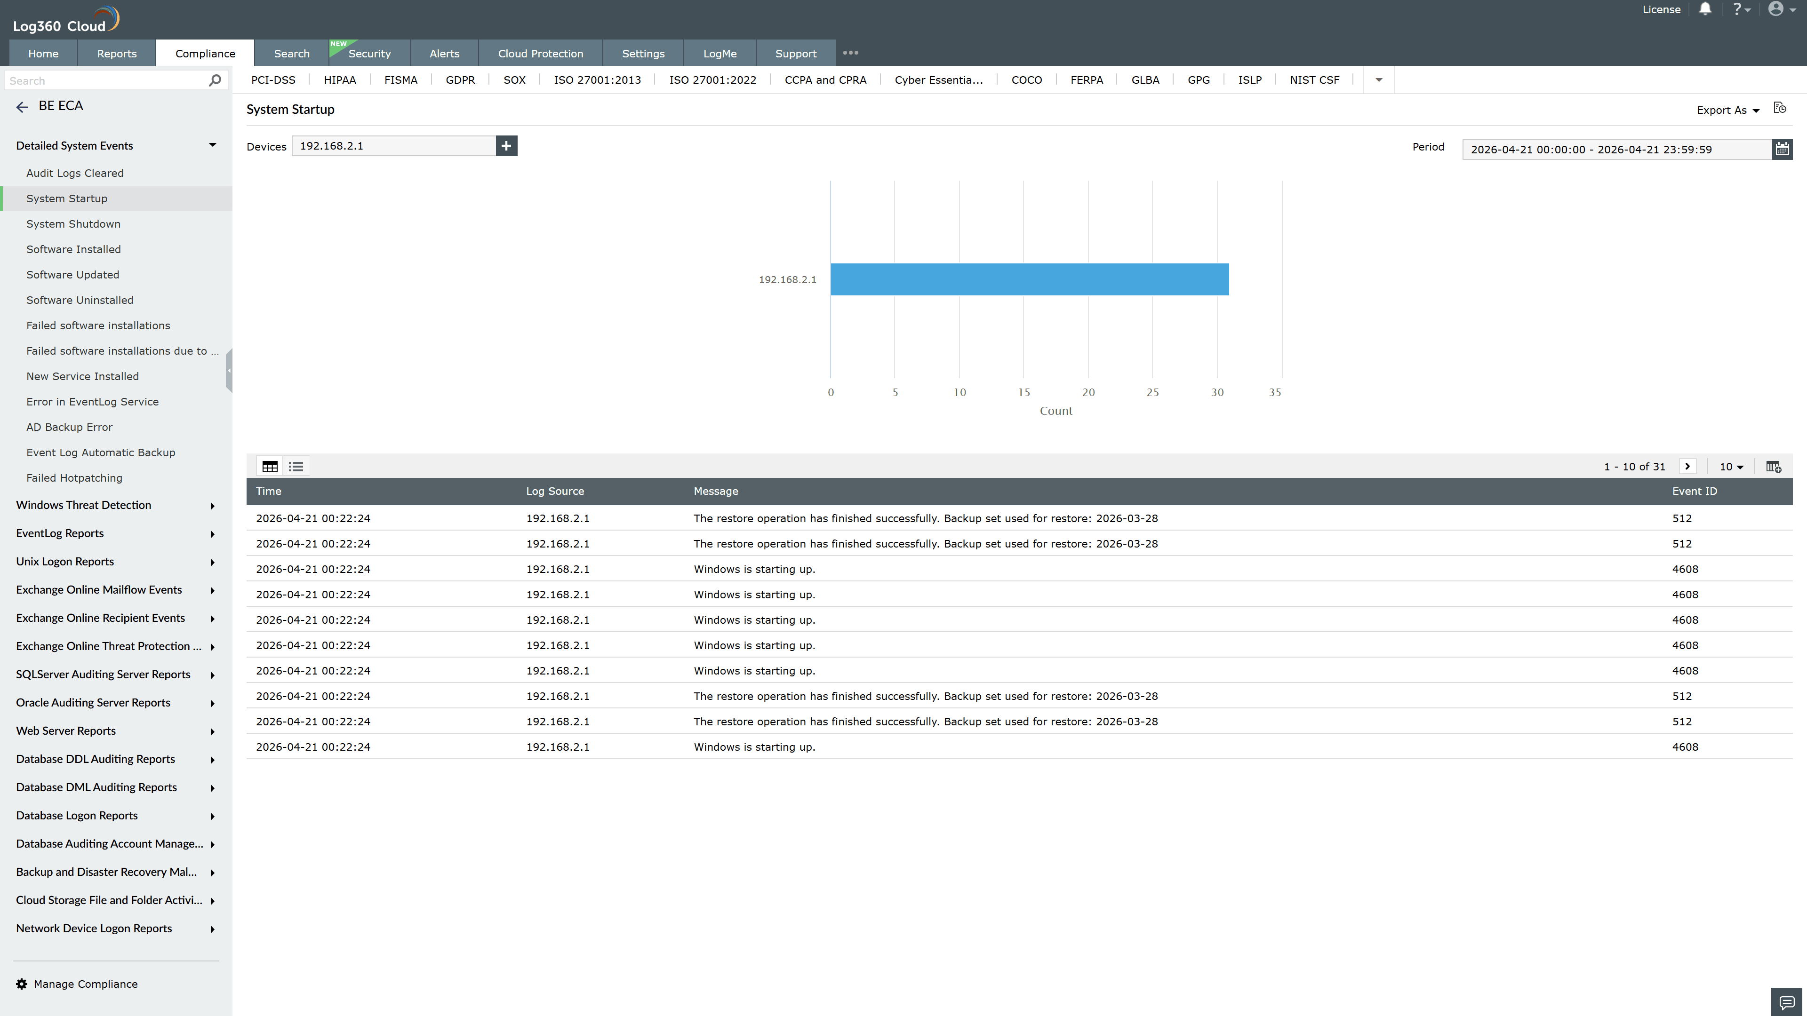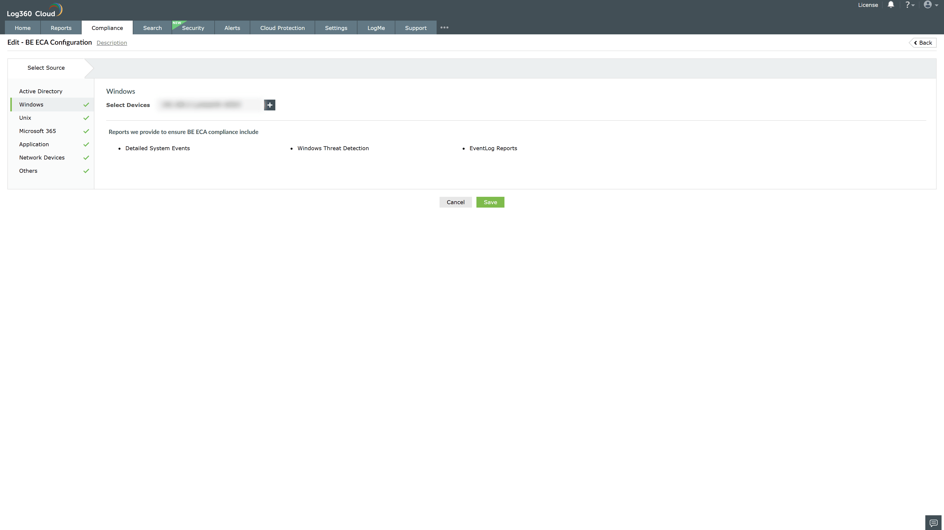
Valid Submission : Yes
Supported Editions : Free, Basic, Standard, Professional, MSSP
Help Document : https://www.manageengine.com/log-management/help/integrations/compliance-extensions.html
Help Video : Not provided
Tags : Log360, Compliance, Privacy monitoring, Data privacy, Regulatory compliance
Supported DCs : US, IN, JP, CA, AU, UK and EU
Privacy Policy:
Terms of Service:
Release Notes:
Predefined reports for the BE ECA Compliance.

